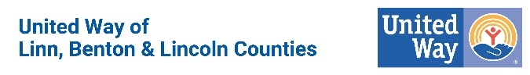

Your gift matters. United Ways serving Linn, Benton, & Lincoln Counties brings our community’s resources together to ensure a safety net for those who are vulnerable, to help our kids succeed in school, to create a pathway for families to achieve stability, and to take care of our neighbors young and old. We can leverage the dollar to make it go further across the 48 different non-profit agencies we work with regularly. Even the smallest donations go further with United Way.
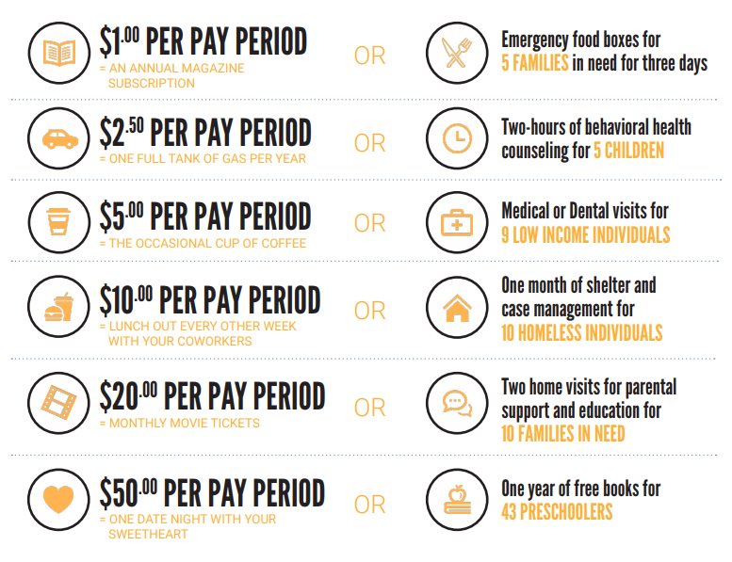

JOIN THE FIGHT (create button with giving link)

United Ways serving Linn, Benton, & Lincoln Counties partner with a wide variety of
organizations across the tri-county footprint to increase impact. We know that change doesn’t happen alone. By funding programs and creating collaborations with other organizations, we can take advantage of pre-existing infrastructure to maximize resources.

And it’s more than the programs. It’s about working together. At United Way we believe no one agency can work on big issues alone. Pooling resources, expertise and time creates more holistic solutions. That’s why United Way ensures through our funding process that we have a healthy eco-system of non-profits able to work in tandem and eliminate gaps.

Below is a list of our current partnerships for this fiscal year. (We can provide a written list, as well, if the image does not work for your email purposes.)

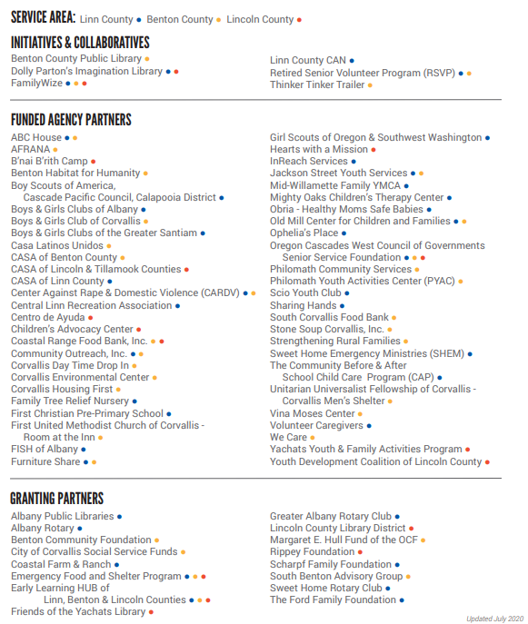

JOIN THE FIGHT (create button with giving link)

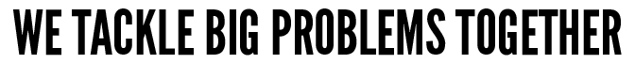
We envision a community where all individuals and families achieve their human potential through education, financial stability and health. But that isn’t the present reality for many of our neighbors across Linn, Benton, & Lincoln Counties.
- 1 in 5 children in our area regularly live in poverty.
- Only 20% of families with children can access pre-school or daycare. For every 100 children, there are only 20 spots available.
- 45% of households in our three counties regularly struggle to make ends meet. In Benton County, 20% of households have annual incomes that are below the federal poverty line.
- On average, 60% of our area third-graders cannot read proficiently. Third-grade reading proficiency is a top indicator as to whether or not children will graduate high school.
- In each of the three counties we represent, there are enough homeless children at any given time to place one child in each classroom.
At United Way, we analyze the stats and invest in solutions that work. Each organization that receives funding must provide measurable outcomes and report on those successes periodically. You can be sure that your dollar is going to our community’s most pressing issues and is applied as efficiently as possible when you donate to United Way.
JOIN THE FIGHT (create button with giving link)

United Way of Linn, Benton & Lincoln Counties strives to improve lives from Cascades to Coast. Since 1955, we’ve been a local organization helping local Oregonians. So, the money raised here, stays here.
Our mission is to mobilize the resources and people of our communities in collective action to address our most pressing challenges.
We envision communities where all individuals and families have the opportunity to achieve their potential.
 |  | 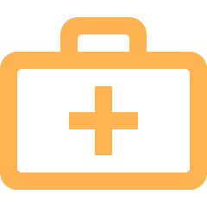
 |  | 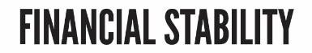
Success in life begins with a quality education. And yet, many children and youth lack the support they need to strengthen their literacy, stay on track in school, graduate high school and find a career. | Chronic unemployment. Financial illiteracy. Homelessness. In communities across Linn, Benton & Lincoln Counties individuals and families are facing financial obstacles that prevent a good quality of life. | By making it easier for individuals to access substance abuse programs, receive quality health care and access nutritious foods, we’re fighting to help everyone get—and stay—healthy.

We do more than raise money. We step up. We join in. We set bold goals and measure progress to ensure we’re making the biggest impact possible. We identify gaps in existing local services and build new programs to fill them. We partner with local nonprofits, companies, volunteers and community members to create lasting change. Together, we’re solving our ​biggest problems for today, tomorrow and forever.
- We Raise Money
  - We work with a dedicated group of volunteers and Campaign Coordinators who lead their companies and organizations to raise more than $1 million in contributions each year.
- We Vet Agencies
  - We do the due diligence that individual donors don’t always have the time, resources, or knowledge to do. Local people volunteer their time to vet all of the nonprofits we fund in the areas of quality programming, governance, finance, and sustainability.
- We Fund Solutions
  - We empower people to unite and solve complex problems. Our fundraising campaign dollars are allocated to address the immediate basic needs of local families and strategically solve systemic barriers to education, financial stability, and health.

JOIN THE FIGHT (create button with giving link)

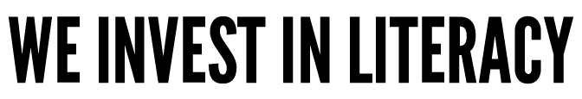
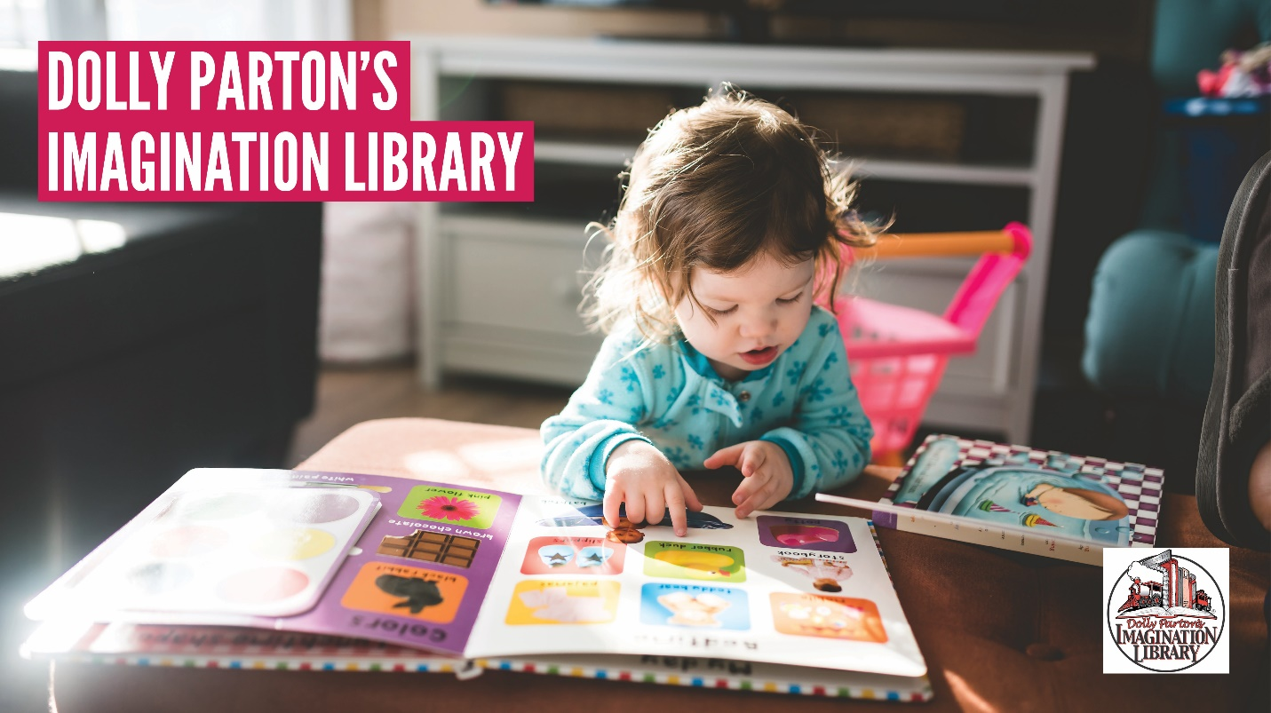

Locally, United Way serves as our region’s coordinator for the ever-popular literacy program, Dolly Parton’s Imagination Library (DPIL.) Dolly Parton’s Imagination Library is a book gifting program that mails free, high-quality books to children from birth until they begin school, no matter their family’s income. Each month a new, carefully selected, age-appropriate book (also available in Spanish and Braille) will be mailed in your child’s name directly to your home. Best of all, it is FREE! There is no cost to the family. Preschool children aged birth to five who are residents of Linn, Rural Benton, and Lincoln Counties are eligible to participate. Check to see if your household qualifies here: http://www.unitedwaylbl.org/imaginationlibrary.
Not only is this program popular, it is proving effective. In partnership with Greater Albany Public Schools, we decided to measure literacy rates among children who had participated in the program. According to GAPS 2018-2019 Kindergarten Readiness Scores, participants enrolled in DPIL for 18 months or more increased:
Length in Program  (# of Students) | Uppercase Letter Recognition  (% better than non-DPIL) | Lowercase Letter Recognition  (% better than non-DPIL) | Letter-Sound Recognition (% better than non-DPIL)
>1.5 years (137) | + 15.7% | + 13.1% | + 33.3%
>3.0 years (40) | + 25.2% | + 18.7% | + 63.9%

Thanks to our generous sponsors, we have officially mailed out more than 100,000 books in 2020!
- Linn County: 105,882 books to date
- Rural Benton County: 1,829 books to date
- Lincoln County: 21,399 books to date
If literacy is important to you, we encourage you to join our fight! Donate today.

JOIN THE FIGHT (create button with giving link)
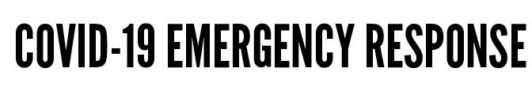
In March 2020, United Way quickly established our area's first COVID-19 Emergency Fund to aid both families & individuals impacted by economic hardship as well as to aid non-profits in expanding current services and mitigate fundraising shortfalls due to canceled events.
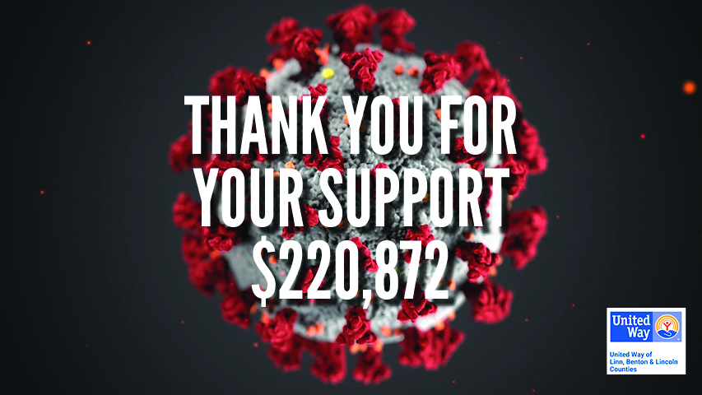

Thanks to donors like you, we were able to fund grants at more than 30 area non-profits to help with childcare for first responders, operational grants & increased programmatic support, rental assistance, and food & hygiene supplies.

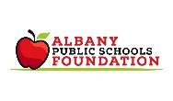 | 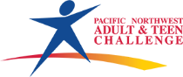 | 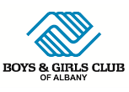 |  |  | 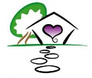
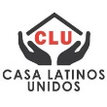 | 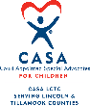 | 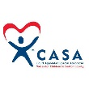 |  | 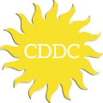 | 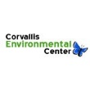
Corvallis Mens’ Shelter | 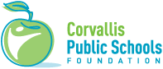 | 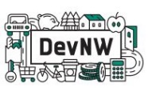 | 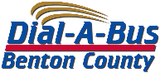 | 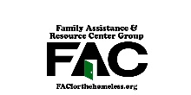 | 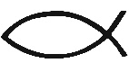
FISH of Lebanon | 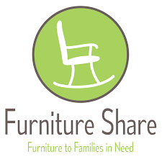 | 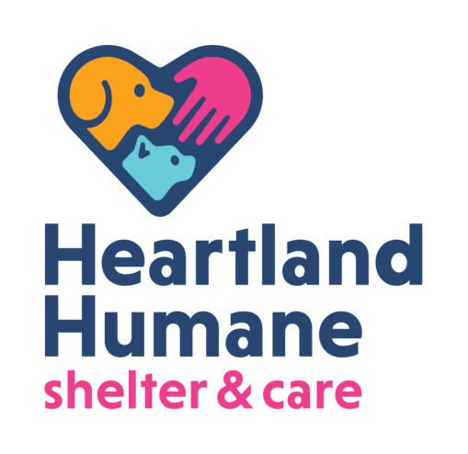 | 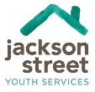 | Lebanon Gleaners | 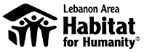
Linn County Animal Rescue | 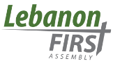 | 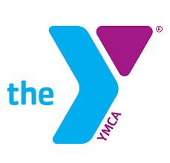 | 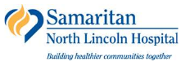 | 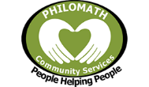 | 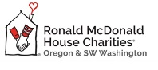
 | 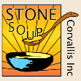 | 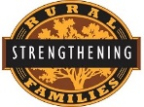 | 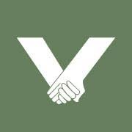 | 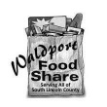

But we are not out of the woods yet. Our area non-profits continue to struggle financially as demand surges. Join our fight to today to protect our safety net.
JOIN THE FIGHT (create button with giving link)

In September 2020, United Way established an emergency fund to directly aid individuals & families displaced or impacted by wildfires across our three-county footprint. 100% of dollars raised have been used to help individuals and families directly. This has been our area’s largest fund to date.

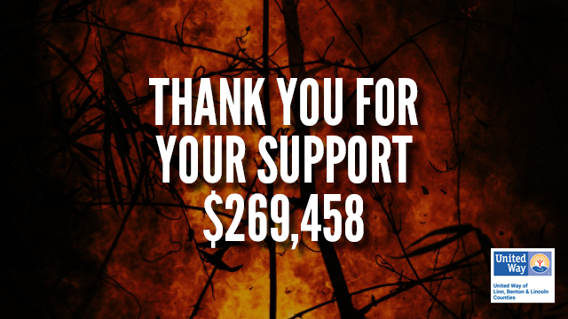

As we transition from immediate relief and move towards the longer-term rebuilding efforts, United Way will be there every step of the way. Check out the grants we have made so far:
- Mid-Willamette Family YMCA: Emergency Air Quality Supplies for Childcare
- FISH of Lebanon: Emergency Aid for Fire Evacuees
- Strengthening Rural Families: Santiam Canyon Early Childhood Center Rebuild
- Furniture Share: Furniture Donations & Distribution
- Vina Moses: Vouchers for Evacuee Donations
- Centro de Ayuda: General Fire Response
- Family Promise of Lincoln County: Echo Mountain Fire Emergency Needs
- Shiloh the Gathering Place: Echo Mountain Fire Emergency Needs
- Samaritan North Lincoln Hospital Foundation: Employee Emergency Fund
- Hearts with a Mission: Sheltering for Children & Families

To join our fight and help local fire victims now, please consider donating today.
JOIN THE FIGHT (create button with giving link)

